**Auto Marking Program Guideline**

**Things to do for Go-Back-N Chat**

1. Before you make a program, You consider a rules that we provide
   1. You must be send to data that we set
   2. Window size that you have to set is 6

1. You have to make a program structure that p2p(server and program) and multi thread

(Future work)

1. This program will send to you about nak-number randomly, so you must be a correspond with nak-number.
2. After send to signal about nak, you have to send a sequence correspond that rules of GBN.

**What you can get in this project**

you can understand knowledge about sliding window protocol. And you get a how to make a chat program**.**

**List of grading items**

* 1. Mission1: Data validation

- You have to send a data ‘mirlabmirlab’

* 1. Mission2: ACK & NAK Check

- Reponse about NAK that sent from server

* 1. Mission3: Correct Sequence

- After mission 2 complete, you have to send a sequence correspond that rules of GBN.

* 1. Mission4: Set window size

-You have to set a window size is six

**How to test?**

* + 1. Approach *166.104.143.225/index* through your web browser (Internet Explorer, Chrome, Firefox and etc.)

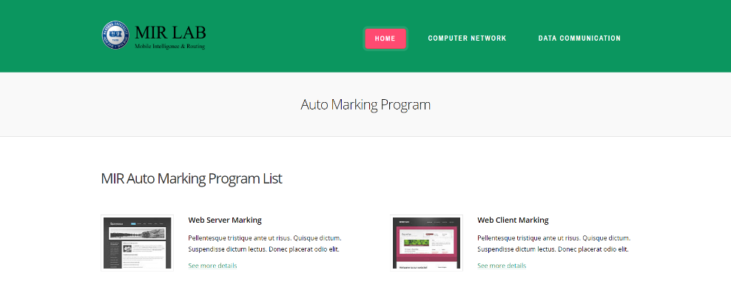

* + 1. You have to choice in list association with your project (In this case, you should choose Go back N)

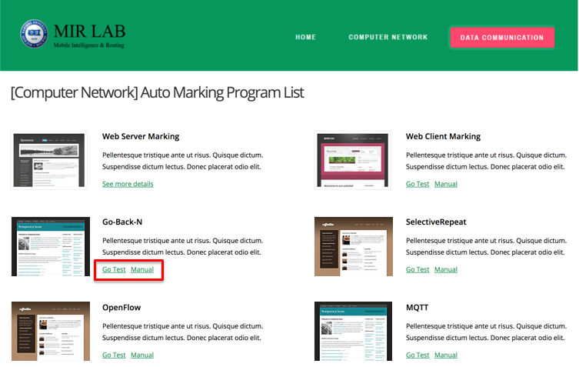

* + 1. Fill out your information on blank.

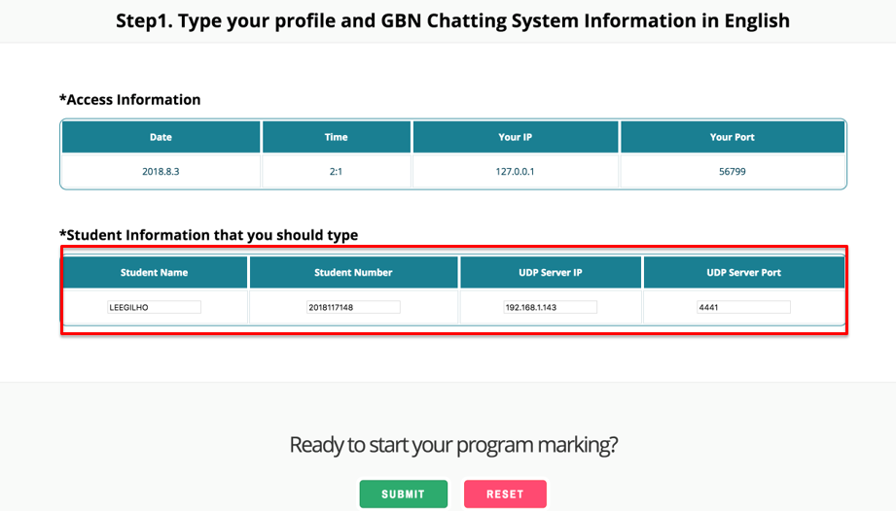

* + - * 1. Student Number(2017xxxxx)
        2. Student Name (Should be written in English)
        3. Your Web Server IP Address. If you are hard to find your global IP, refer to Current Connection Info in case you approaches this web site with the same computer
        4. Port that you assign for your Web server, Check this out on your Source Code
    1. In this step, you check to mission that we provide before run your program

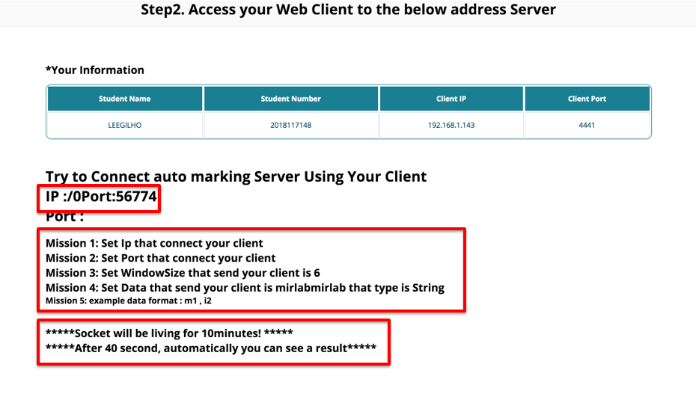

You must be a think before run your chat program

* + 1. Set IP and PORT we gave
    2. Set your Window size is 6
    3. Data format you send is, for example ‘m1,i2,r3..’( ‘m’ is data , ‘1’ is sequence number)
    4. After forty second, your test will be a end
    5. Socket that you use is a setting that end after 10minute. So after click submit button, for 10minute your test is must be a end.
    6. If you want to test again, have to return step 2

* + 1. Result Page

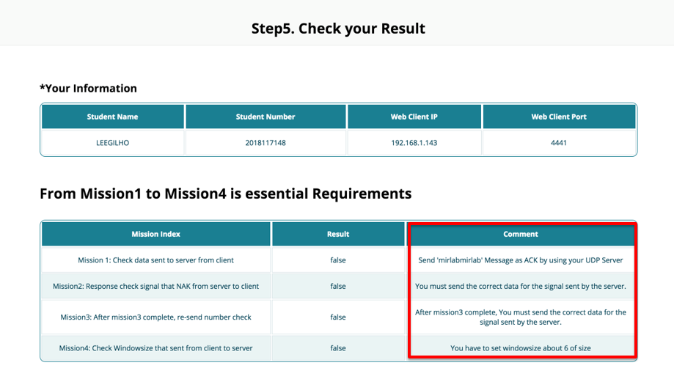

1. You can see what is wrong or correct with Reason